Contents

Introduction 1

Quigley, Tragedy and Hope 1

Simpson, Colin. *Lusitania.* 1

20081219 Arms find 1

WWI (Copy from Separate Doc, The Corbett Report) 1

## Introduction

Every section is about the Lusitania.

## Quigley, Tragedy and Hope

……. As John Bassett Moore, America's most famous international lawyer, put it, "What most decisively contributed to the involvement of the United States in the war was

1. the assertion of a right to protect belligerent ships on which Americans saw fit to travel and
2. the treatment of armed belligerent merchantmen as peaceful vessels. Both assumptions were contrary to reason and to settled law, and no other professed neutral advanced them.''

The Germans at first tried to use the established rules of international law regarding destruction of merchant vessels. This proved so dangerous, because of the peculiar character of the submarine itself, British control of the high seas, the British instructions to merchant ships to attack submarines, and the difficulty of distinguishing between British ships and neutral ships, that most German submarines tended to attack without warning. American protests reached a peak when the Lusitania was sunk in this way nine miles off the English coast on May 7, 1915. The Lusitania was a British merchant vessel "constructed with Government funds as [an] auxiliary cruiser, . . . expressly included in the navy list published by the British Admiralty," with "bases laid for mounting guns of six-inch caliber," carrying a cargo of 2,400 cases of rifle cartridges and 1,250 cases of shrapnel, and with orders to attack German submarines whenever possible.

Seven hundred and eighty-five of 1,257 passengers, including 128 of 197 Americans, lost their lives. The incompetence of the acting captain contributed to the heavy loss, as did also a mysterious "second explosion" after the German torpedo struck. The vessel, which had been declared "unsinkable," went down in eighteen minutes. The captain was on a course he had orders to avoid; he was running at reduced speed; he had an inexperienced crew; the portholes had been left open; the lifeboats had not been swung out; and no lifeboat drills had been held.

The propaganda agencies of the Entente Powers made full use of the occasion. The Times of London announced that "four-fifths of her passengers were citizens of the United States" (the actual proportion was 15.6 percent); the British manufactured and distributed a medal which they pretended had been awarded to the submarine crew by the German government; a French paper published a picture of the crowds in Berlin at the outbreak of war in 1914 as a picture of Germans "rejoicing" at news of the sinking of the Lusitania.

The United States protested violently against the submarine warfare while brushing aside German arguments based on the British blockade. It was so irreconcilable in these protests that Germany sent Wilson a note on May 4, 1916, in which it promised that "in the future merchant vessels within and without the war zone shall not be sunk without warning and without safeguarding human lives, unless these ships attempt to escape or offer resistance." In return the German government hoped that the United States would put pressure on Britain to follow the established rules of international law in regard to blockade and freedom of the sea. Wilson refused to do so. Accordingly, it became clear to the Germans that they would he starved into defeat unless they could defeat Britain first by unrestricted submarine warfare. Since they were aware that resort to this method would probably bring the United States into the war against them, they made another effort to negotiate peace before resorting to it. When their offer to negotiate, made on December 12, 1916, was rejected hy the Entente Powers on December 27th, the group in the German government which had been advocating ruthless submarine warfare came into a position to control affairs, and ordered the resumption of unrestricted submarine attacks on February 1, 1917. Wilson was notified of this decision on January 31st. He broke off diplomatic relations with Germany on February 3rd, and, after two months of indecision, asked the Congress for a declaration of war April 3, 1917. The final decision was influenced by the constant pressure of his closest associates, the realization that Britain was reaching the end of her resources of men, money, and ships, and the knowledge that Germany was planning to seek an alliance with Mexico if war began.

While the diplomacy of neutrality and intervention was moving along the lines we have described, a parallel diplomatic effort was being directed toward efforts to negotiate peace. These efforts were a failure but are, nonetheless, of considerable significance because they reveal the motivations and war aims of the belligerents. They were a failure because any negotiated peace requires a willingness on both sides to make those concessions which will permit the continued survival of the enemy. In 1914-1918, however, in order to win public support for total mobilization, each country's propaganda had been directed toward a total victory for itself and total defeat for the enemy.

……..

## Simpson, Colin. *Lusitania.*

The Morgan interests, in concert with Winston Churchill, tried to bring the U.S. into World War I as early as 1915 and succeeded in doing so in 1917. Colin Thompson's *Lusitania*

implicates President Woodrow Wilson in the sinking of the *Lusitania* — a horror device to generate a public backlash to draw the United States into war with Germany. Thompson demonstrates that Woodrow Wilson knew *four darts beforehand* that the *Lusitania* was

carrying six-million rounds of ammunition plus explosives, and therefore, "passengers who proposed to sail on that vessel were sailing in violation of statute of this country."4 The British Board of Inquiry under Lord Mersey was *instructed* by the British Government

"that it is considered politically expedient that Captain Turner, the master of the *Lusitania,* be most prominently blamed for the disaster."

In retrospect, given Colin Thompson's evidence, the blame is more fairly to be attributed to

* President Wilson,
* "Colonel" House,
* J.P. Morgan, and
* Winston Churchill;

this conspiratorial elite should have been brought to trial for willful negligence, if not treason. It is to Lord Mersey's eternal credit that after performing his "duty" under instructions from His Majesty's government, and placing the blame on Captain Turner, he resigned, rejected his fee, and from that date on refused to handle British government commissions. To his friends Lord Mersey would only say about the *Lusitania* case that it was a "dirty business."

Simpson, Colin. *Lusitania.* London; Longman, 1972.

## 20081219 Arms find

Secret of the Lusitania: Arms find challenges Allied claims it was solely a passenger ship

By [SAM GREENHILL FOR THE DAILY MAIL](https://www.dailymail.co.uk/home/search.html?s=&authornamef=Sam+Greenhill+for+the+Daily+Mail)   
**UPDATED:** 20:16 EDT, 19 December 2008

Her sinking with the loss of almost 1,200 lives caused such outrage that it propelled the U.S. into the First World War.

But now [2008] divers have revealed a dark secret about the cargo carried by the Lusitania on its final journey in May 1915.

Munitions they found in the hold suggest that the Germans had been right all along in claiming the ship was carrying war materials and was a legitimate military target.

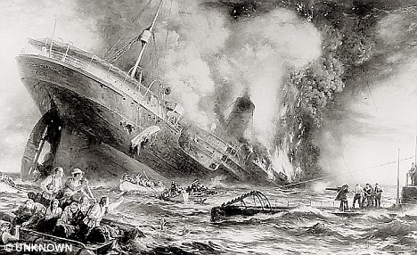

**Doomed: A contemporary view of the sinking of the Lusitania off Ireland in May 1915**

The Cunard vessel, steaming from New York to Liverpool, was sunk eight miles off the Irish coast by a U-boat.

Maintaining that the Lusitania was solely a passenger vessel, the British quickly accused the 'Pirate Hun' of  
slaughtering civilians.

The disaster was used to whip up anti-German anger, especially in the U.S., where 128 of the 1,198 victims came from.

A hundred of the dead were children, many of them under two.

Robert Lansing, the U.S. secretary of state, later wrote that the sinking gave him the 'conviction we would ultimately become the ally of Britain'.

Americans were even told, falsely, that German children were given a day off school to celebrate the sinking of the Lusitania.

The disaster inspired a multitude of recruitment posters demanding vengeance for the victims.

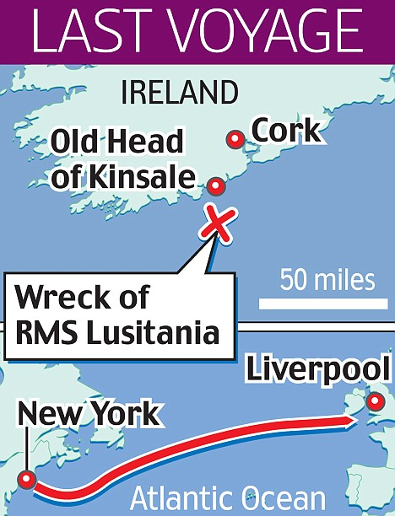

One, famously showing a young mother slipping below the waves with her baby, carried the simple slogan 'Enlist'.

Two years later, the Americans joined the Allies as an associated power  -  a decision that turned the war decisively against Germany.

The diving team estimates that around four million rounds of U.S.-manufactured Remington .303 bullets lie in the Lusitania's hold at a depth of 300ft.

The Germans had insisted the Lusitania  -  the fastest liner in the North Atlantic  -  was being used as a weapons ship to break the blockade Berlin had been trying to impose around Britain since the outbreak of hostilities in August 1914.

Winston Churchill, who was first Lord of the Admiralty and has long been suspected of knowing more about the circumstances of the attack than he let on in public, wrote in a confidential letter shortly before the sinking that some German submarine attacks were to be welcomed.

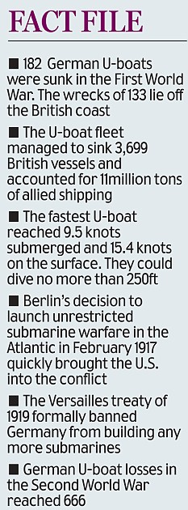

He said: 'It is most important to attract neutral shipping to our shores, in the hope especially of embroiling the U.S. with Germany.

'For our part we want the traffic  -  the more the better and if some of it gets into trouble, better still.'

Hampton Sides, a writer with Men's Vogue in the U.S., witnessed the divers' discovery.

He said: 'They are bullets that were expressly manufactured to kill Germans in World War I  -  bullets that British officials in Whitehall, and American officials in Washington, have long denied were aboard the Lusitania.'

The discovery may help explain why the 787ft Lusitania sank within 18 minutes of a single German torpedo slamming into its hull.

Some of the 764 survivors reported a second explosion which might have been munitions going off.

Gregg Bemis, an American businessman who owns the rights to the wreck and is funding its exploration, said: 'Those four million rounds of .303s were not just some private hunter's stash.

'Now that we've found it, the British can't deny any more that there was ammunition on board. That raises the question of what else was on board.

'There were literally tons and tons of stuff stored in unrefrigerated cargo holds that were dubiously marked cheese, butter and oysters.

'I've always felt there were some significant high explosives in the holds  -  shells, powder, gun cotton  -  that were set off by the torpedo and the inflow of water. That's what sank the ship.'

Mr Bemis is planning to commission further dives next year in a full-scale forensic examination of the wreck off County Cork.

## WWI (Copy from Separate Doc, The Corbett Report)

In 1915, the RMS Lusitania, a British ocean liner en route from New York to Liverpool, was sunk by a German U-boat 11 miles off the coast of Ireland. The ship’s sinking, which resulted in the death of 128 of the 139 Americans aboard, became a symbol of German evil and helped psychologically prepare the US public for their country’s eventual entry into WWI. But every facet of the story of the Lusitania as it has been presented to the public was a deliberate lie or a lie by omission.

The boat was *not* a purely civilian vessel carrying 3,813 40-pound (unrefrigerated) containers of “cheese” and 696 containers of “butter,” as the [official manifest](http://www.rmslusitania.info/downloads/crossing202_supplementary_cargo_manifest.pdf) held, but guncotton, in keeping with the shipment’s [stated destination](http://www.lusitania.net/deadlycargo.htm): the Royal Navy’s Weapons Testing Establishment.

It was *not* sunk by the German torpedo boat but by secondary explosions from [the munitions the ship was (illegally) carrying](https://www.npr.org/templates/story/story.php?storyId=97350149).

It was *not* the victim of a cowardly German surprise attack (the German Embassy placed a [warning notice](https://en.wikipedia.org/wiki/File:Lusitania_warning.jpg) about the Lusitania in 50 American newspapers right next to Cunard’s own listings).

And the American ambassador to England at the time, Walter Hines Page, wrote to his son five days before the ship was sunk, [asking](https://books.google.co.jp/books?id=m70fBgAAQBAJ&pg=PA95&dq=%22%E2%80%9CIf+a+British+liner+full+of+American+passengers+be+blown+up,+what+will+Uncle+Sam+do?%22&hl=en&sa=X&ved=0ahUKEwjIkI38h7_cAhWKVLwKHSNsD_EQ6AEINjAC#v=onepage&q=%22%E2%80%9CIf%20a%20British%20liner%20full%20of%20American%20passengers%20be%20blown%20up%2C%20what%20will%20Uncle%20Sam%20do%3F%22&f=false): “If a British liner full of American passengers be blown up, what will Uncle Sam do? That’s what’s going to happen.”

So what did the official cover-up of the incident conclude? That the dastardly Germans had waged a perfidious sneak attack on an innocent peace boat, of course. And the rest, as they say, is history.